NAVAL PUMP TEST AUTOMATION & DIGITAL ENGINEERING CAPABILITY
CAGE: 1SGJ4
Automating Complex Systems. Delivering Actionable Data. Advancing Mission Success.
Data Science Automation (DSA) develops advanced automation, data acquisition, control, and digital engineering solutions for Department of Defense, NASA, and Federal Government customers. DSA specializes in transforming complex testing and validation processes into automated, repeatable, and data-driven systems that improve product quality while reducing testing time, operational risk, and lifecycle costs.
CORE COMPETENCIES
• Automated Test and Evaluation (T&E) Systems
• Real-Time Data Acquisition and Monitoring
• Naval and Fluid System Testing
• Hardware-in-the-Loop (HIL) Simulation
• LabVIEW and National Instruments Architectures
• Data Logging, Analytics, and Reporting
• Verification and Validation Support
RELEVANT PROJECT EXPERIENCE
NAVAL PUMP TEST AUTOMATION SYSTEM
DSA designed and implemented an automated test platform for characterization and validation of a naval pump system. The solution integrated thirty-eight analog input channels and dual analog output control channels to automate testing, monitor critical operational parameters, and collect high-fidelity performance data.
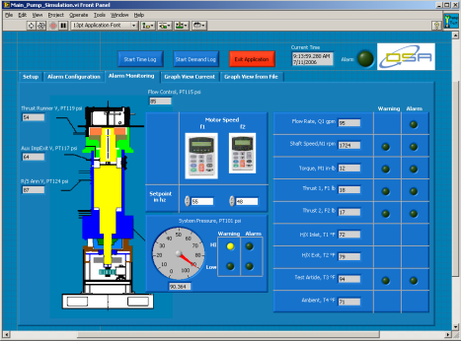
Key capabilities included:
• Automated monitoring of 40+ sensor channels • Real-time collection of pressures, temperatures, flow rates, torque, thrust, motor current, and rotational speed • Automated Variable Frequency Drive (VFD) control through analog output setpoints • User-configurable alarm thresholds and shutdown protection • Multi-tiered data logging architecture supporting long-duration trend analysis, event-driven capture, and alarm-based recording • Interactive operator interface modeled after the system under test • Real-time and historical trend visualization tools • State-machine software architecture supporting rapid modification and future capability growth
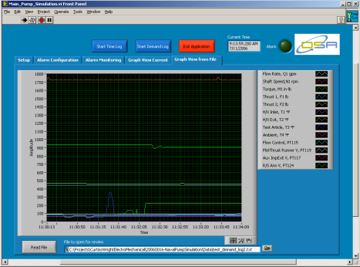
MISSION IMPACT
The automated test system reduced operator workload, improved repeatability, accelerated test execution, and increased the quantity and quality of engineering data available for analysis. Built-in alarm management and automated shutdown capabilities enhanced equipment protection while supporting reliable validation of naval pump performance under operational conditions.
DIFFERENTIATORS
• Proven experience supporting federal and defense customers • Expertise in National Instruments and LabVIEW development • Rapid deployment of custom test and automation solutions • Integrated hardware, software, controls, and data acquisition capabilities • Scalable architectures supporting future system enhancements
CUSTOMERS SERVED
NASA | Department of the Navy | NAVSEA | Army | Air Force | NIH

